PA Redistricting Package Guide

Overview
pa_redistricting is a Python package that scores Pennsylvania Senate citizen redistricting plans. It replaces six numbered step scripts with modules that each do one job, plus one command-line entry point and a run_all.py script that makes every output in one go.
For each plan it can:
- Join the plan's district assignments to 2020 voting-district shapes and Census counts
- Summarize population balance and demographics for each of the 50 Senate districts
- Draw a map with consistent district colors across plans
- Score partisan asymmetry: efficiency gap, partisan bias, mean-median difference and declination
It can be run from the terminal, used from a notebook, or imported into a web app. The library code never prompts, prints reports or writes files, so it works the same in all three.

From step scripts to modules
Each step's calculations moved into a library module; everything that prompts, prints or saves files moved into cli.py. The results are unchanged.
Old script | Calculations moved to | Moved to cli.py
step1_plan_assignments.py | plan_assignments.py (plan CSVs), voting_districts.py (VTD shapes) | list command
step2_census_data.py | census.py | codebook command
step3_plans.py | plans.py | Plan selection menu
step4_plan_maps.py | maps.py | Saving PNGs (maps command)
step5_plan_summary.py | population.py | Printed report, CSVs (summary command)
step6_partisan_metrics.py | partisan_metrics.py, election_results.py | Printed report, CSVs (partisan command)
Constants in every step | config.py | —
Two files have no old counterpart: __init__.py lists what can be imported from the package, and __main__.py lets it run as python -m pa_redistricting.

Module reference
The modules form five layers. Library modules return data; only cli.py talks to a person or the disk.
Layer | Module | Key functions | Returns
Settings | config.py | N_DISTRICTS, STATE_FIPS, PLAN_HEADER, data URLs | Constants
Data source | plan_assignments.py | fetch_plan_assignments(), read_assignment(text) | {plan name: DataFrame[GEOID, district]}; raises ValueError on a bad header
Data source | voting_districts.py | load_vtds() | GeoDataFrame, one row per voting district
Data source | census.py | fetch_census(api_key=None), fetch_codebook() | Census counts per voting district; raises MissingAPIKeyError with no key
Data source | election_results.py | fetch_elections(), available_elections(), ELECTIONS | Vote counts per voting district
Joining | plans.py | Plans.load(), plans.get(name), plans.match(words), plans.all() | One plan per call, one row per voting district
Analysis | population.py | population_summary(df) | Table per Senate district + overall stats
Analysis | maps.py | plot_plan(gdf, title) | matplotlib Figure
Analysis | partisan_metrics.py | partisan_summary(plan_df, votes) | Four metrics per election + per-district votes
Front end | cli.py | run, list, summary, maps, partisan, codebook commands; run_everything() for scripts and IDEs | Printed reports, CSVs, PNGs
The Census key comes from the api_key argument, then the CENSUS_API_KEY environment variable. Plans.load(census_api_key=...) passes it through.

How the modules connect
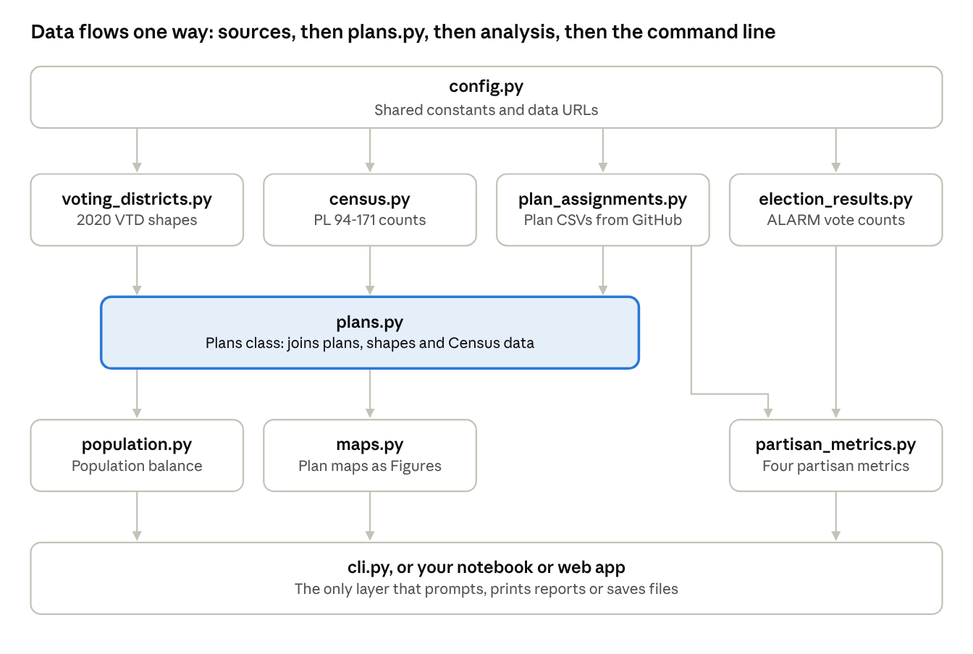
module dependencies · 5 layers, 10 modules
Imports only point downward, so each module can be used or tested alone. partisan_metrics.py takes plans and votes directly, skipping plans.py, which is why it needs no shapes or Census key.

Setup and running
Install once, then run commands; there is no required order, since each command downloads what it needs. To make every output in one go, use run --all or run_all.py (below).
One-time setup (PowerShell, in the project folder, with the conda environment active):
- python -m pip install -e ".[test]" installs the package in editable mode, plus pytest.
- Set the Census key with no spaces around =: conda env config vars set CENSUS_API_KEY=<key> -n gus8066, then deactivate and reactivate. The key is needed for run, summary and maps; list, codebook and partisan work without it.
- Run pytest to confirm the install; all tests should pass.
Commands
Task | Command | Output
Everything in one go | python -m pa_redistricting run --all | results/
List plans, check files | python -m pa_redistricting list | Printed list
Population summary | python -m pa_redistricting summary allentown | summaries/
Maps | python -m pa_redistricting maps --all | maps/
Partisan metrics | python -m pa_redistricting partisan --all | partisan/
Census column labels | python -m pa_redistricting codebook | Printed table
Plan words match parts of plan names; --all runs every plan; no words shows a numbered menu. --out FOLDER changes the output folder and -q hides progress messages.
In VS Code, select the gus8066 interpreter and open the project folder. To make every output at once, open run_all.py and press Run; edit PLANS and OUT at the top of the file to choose plans and the output folder. Commands can also be typed in the integrated terminal.
Output of run: results/ holds overview.csv (one row per plan: population balance plus the composite election's partisan metrics), summaries/, maps/ and partisan/ (partisan_metrics.csv with every plan under every election, plus votes and winner per district).
Census key in VS Code: the Run button uses its own terminal. If it reports a missing key, close VS Code's terminals (or restart VS Code) so a fresh one loads the key from gus8066. Run and Debug (F5) does not see conda's variables and reads a .env file holding CENSUS_API_KEY instead; keep that file out of Git. The tests never need a key.
In Python or a notebook:
from pa_redistricting import Plans, population_summary, plot_plan
plans = Plans.load()
table, stats = population_summary(plans.get(plans.names[0], geometry=False))
fig = plot_plan(plans.get(plans.names[0]), plans.names[0])

Design decisions
The structure answers three review comments: the scripts were siloed, the "Step n" names described order rather than purpose, and there were no tests.
Decision | Why
One module per job, named for that job | A name like census.py says what is inside; step2_census_data.py only says when it was written
Library returns data; only cli.py prompts, prints or saves | The same code works in a terminal, notebook or web app, where input() cannot be answered
Imports flow one way: data sources → plans.py → analysis → cli.py | Any module can be used or tested without loading the rest
Shared constants in config.py | A value such as the seat count changes in one place
Data passed in as arguments (API key, plan table, votes) | Tests use small made-up tables and never touch the network
Plan files must have the header GEOID20,District | A bad file stops the run with its name, instead of being skipped silently
Census key from an argument or CENSUS_API_KEY, never typed in | Keys stay out of the code; a missing key raises MissingAPIKeyError
Maps built as a plain matplotlib Figure, without pyplot | pyplot's global state is meant for interactive windows and misbehaves on servers
Partisan metrics use only plans and votes | No shapefile download and no Census key needed for that command
One run command and run_all.py | Downloads the data once and writes every output to one folder, so nothing has to be run in order; the terminal command and the Run button share run_everything()
The calculations are identical to the step scripts, so results already checked still hold. The package has also been run end to end against the real downloads for all 50 plans, and all four elections in ELECTIONS were found.

Limitations and next steps
Current limitations
- Every run downloads all data again; there is no local cache.
- Plans must use 2020 voting districts (11-character GEOIDs; the last six characters may include letters, as in 4200300F437). A plan that splits a voting district would need block-level data.
- Partisan metrics use statewide races as a stand-in for Senate voting, and leave out votes in unassigned voting districts.
- The maps command needs a Census key even though maps use no Census data, because it loads everything through Plans.load().
- Declination omits PlanScore's chamber-size adjustment, so it won't match PlanScore's published values exactly.
Possible next steps
- ☐ Cache downloads on disk, or in a GeoPackage, so repeat runs are fast
- ☐ Let maps load without Census data, so it needs no key and runs faster
- ☐ Add a function that merges each plan's voting districts into district polygons, for compactness scores and web maps
- ☐ Build a web app (Flask or Streamlit) on top of the library, alongside cli.py

Data sources
Data | Source | Used by
Citizen plans (GEOID → district) | ccfdpa/pa-citizen-redistricting-plans-2020, pa-senate folder | plan_assignments.py
Voting-district shapes | 2020 Census TIGER/Line VTDs for Pennsylvania | voting_districts.py
Population, race, housing | 2020 Census Redistricting Data (PL 94-171) API | census.py
Votes per voting district | ALARM Project 2020 data (alarm-redist/census-2020) | election_results.py
Metric definitions | PlanScore metrics | partisan_metrics.py
